Case Study 2- NLP Services on FastAPI, Streamlit and Snowflake

| **Summary** | In this codelab, I have used different technologies to built NLP services like Summarization, Named Entity Recognition and Word Embedding, For backend I have used FastAPI and to store data I have used Snowflake, and Frontend I have used Streamlit and deployed it. |
| --- | --- |
| **URL** |  |
| **Category** | Natural Language Processing |
| **Environment** | FastAPI, Streamlit, Snowflake, Docker, Git, Visual Studio Code |
| **Status** | Not Published |
| **Author** | Tanvi Tembhurne |

Introduction

Overview

SnowFlake

HuggingFace

Tensorflow Hub

FastAPI

IBM

Streamlit

Docker

Requirements for FastAPI

Requirements for Streamlit

Snowflake Code Snippet

Transformer-HuggingFace-Summarization-FastAPI Code Snippet

Tensorflow-BertModel-Named Entity Recognition- FastAPI Code Snippet

Tensorflow-Wiki_words_250Model-Word Embedding-FastAPI Code Snippet

Connecting FastAPI to Streamlit Code Snippet

Connecting IBM_API to Streamlit Code Snippet

Dockerize FastAPI

Dockerize Streamlit

Docker-Compose (Merging two container into one)

FastAPI WebInterface

Streamlit WebInterface

Deployment on Web

# Introduction

This case study is dedicated to do Summarization, Named Entity Recognition and Word Embedding for any given data using Transformers and pretrained model from tf.hub and transforming the functions to APIs and calling them from the Frontend that is Streamlit.

# 

# Overview

## Snowflake

Snowflake is **a data warehouse built on top of the Amazon Web Services or Microsoft Azure cloud infrastructure**. The Snowflake architecture allows storage and compute to scale independently, so customers can use and pay for storage and computation separately.

Installation

Follow the official [Link](https://docs.snowflake.com/en/user-guide/python-connector-install.html) for installing python connector

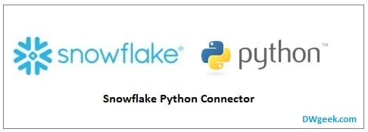

## Hugging Face

The Hugging Face transformers package is **an immensely popular Python library providing pretrained models** that are extraordinarily useful for a variety of natural language processing (NLP) tasks.



## Tensorflow Hub

TensorFlow Hub is **a repository of trained machine learning models**.TensorFlow Hub is a repository of trained machine learning models ready for fine-tuning and deployable anywhere. Reuse trained models like BERT and Faster R-CNN with just a few lines of code.

## FastAPI

FastAPI is a Web framework for developing RESTful APIs in Python. FastAPI is based on Pydantic and type hints to validate, serialize, and deserialize data, and automatically auto-generate OpenAPI documents. It fully supports asynchronous programming and can run with Uvicorn and Gunicorn.

## IBM

Used IBM models and used their API to call from Streamlit.

Named Entity Recognition

## Streamlit

**Streamlit** is an open-source app framework for Machine Learning and Data Science teams. Create beautiful data apps in hours, not weeks. All in pure Python.

## Docker

Docker is an open source containerization platform. It **enables developers to package applications into containers**—standardized executable components combining application source code with the operating system (OS) libraries and dependencies required to run that code in any environment.

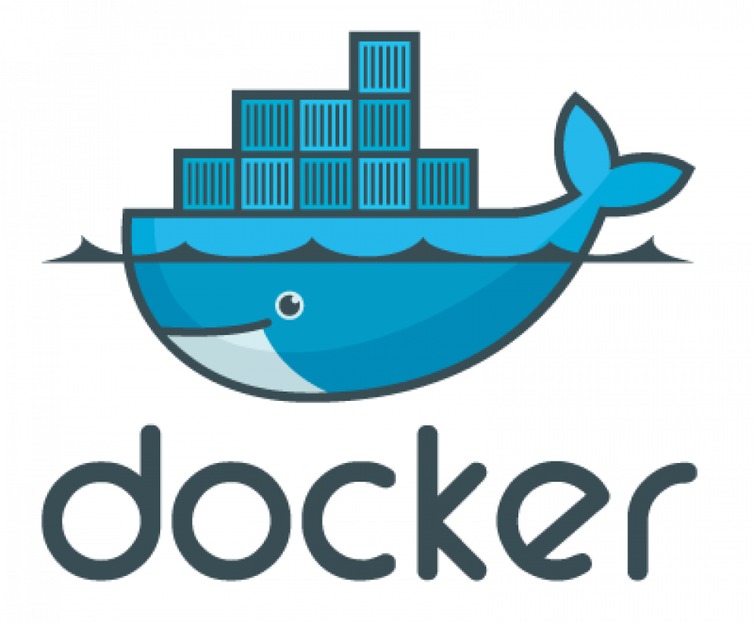

# Requirements for FastAPI

There is requirements.txt file in FastAPI folder which contains all the libraries required

# Requirements for Streamlit

There is requirements.txt file in Streamlit folder which contains all the libraries required

# Snowflake Code Snippet

# Transformer-HuggingFace-Summarization-FastAPI Code Snippet

# Tensorflow-BertModel-Named Entity Recognition- FastAPI Code Snippet

# Tensorflow-Wiki_words_250Model-Word Embedding-FastAPI Code Snippet

# Connecting FastAPI to Streamlit Code Snippet

# Connecting IBM_API to Streamlit Code Snippet

# Dockerize FastAPI

# Dockerize Streamlit

# Docker-Compose (Merging two container into one)

# FastAPI WebInterface

# Streamlit Web Interface

Command to run the Lab

# Deploy using Google cloud Platform

Used CloudRun to deploy the application

FastAPI url: <https://nlpservices-fastapi-v1-th4rn5qo6a-uc.a.run.app>

Streamlit url: <https://nlpservices-streamlit-v1-th4rn5qo6a-uc.a.run.app>